**Heading:**

Document Name: Sprint 2 Plan

Product Name: SlugPath

Team: Slugstras

Sprint Completion Date: February 21, 2018

Revision 1.0 (2-7-18)

**Goal:**

Collect data to populate map with accurate paths. Finish developing shortest path algorithm.

**Task Listing:**

* User Story 1: As a javascript developer, I need to develop the shortest path algorithm so that we can display the shortest path on a visualized map.

User Story 1 Tasks

1. Create difficulty, time, and distance heuristics
2. Create priority queue and graph objects
3. Implement algorithm

* User Story 2: As a data manager, I want to figure out how to represent our data so that our developers can effectively use the data

User Story 2 Tasks

1. Create map nodes for each big node location

* User Story 3: As a developer, I need to sort by nearby attractions so that the users can see nearby attractions.

User Story 3 Tasks

1. Implement sort by area and display by area
2. Implement sort by proximity and display by proximity

* User Story 4: As a developer, I need to create an about page so that we can publicize the team.

User Story 4 Tasks

1. Gather data from team members
2. Implement about page on website

**Team Roles:**

Joven Pableo: Product Owner and Developer

Edward John Tagaca: Developer

Cameron Skaggs: Week 1 Scrum Master, Data Management and Developer

Pranav Salunk: Week 2 Scrum Master and Developer

Srijitha Somangili: Developer

**Initial Task Assignment:**

Joven Pableo: User Story 1: Create difficulty, time, and distance heuristics. User Story 2: Create map nodes for each big node location. User Story 4: Gather data from team members, Implement about page on website

Edward John Tagaca: User Story 2: Create map nodes for each big node location. User Story 3: Implement sort by area and display by area, Implement sort by proximity and display by proximity

Cameron Skaggs: User Story 2: Create map nodes for each big node location

Pranav Salunk: User Story 1: Create priority queue and graph objects, Implement algorithm

Srijitha Somangili: User Story 2: Create map nodes for each big node location

**Initial Burnup Chart:**

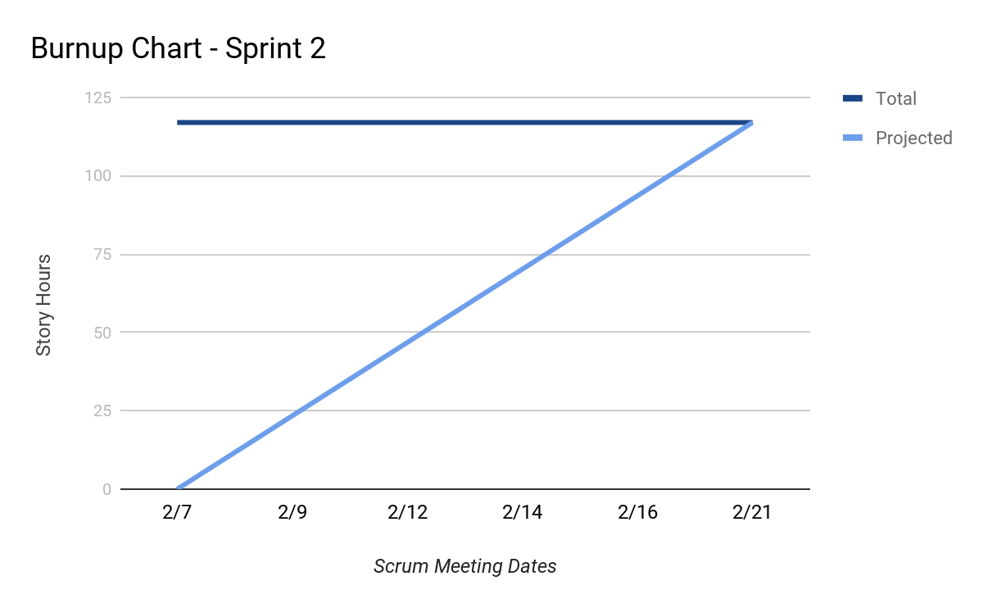

**Initial Scrum Board:**

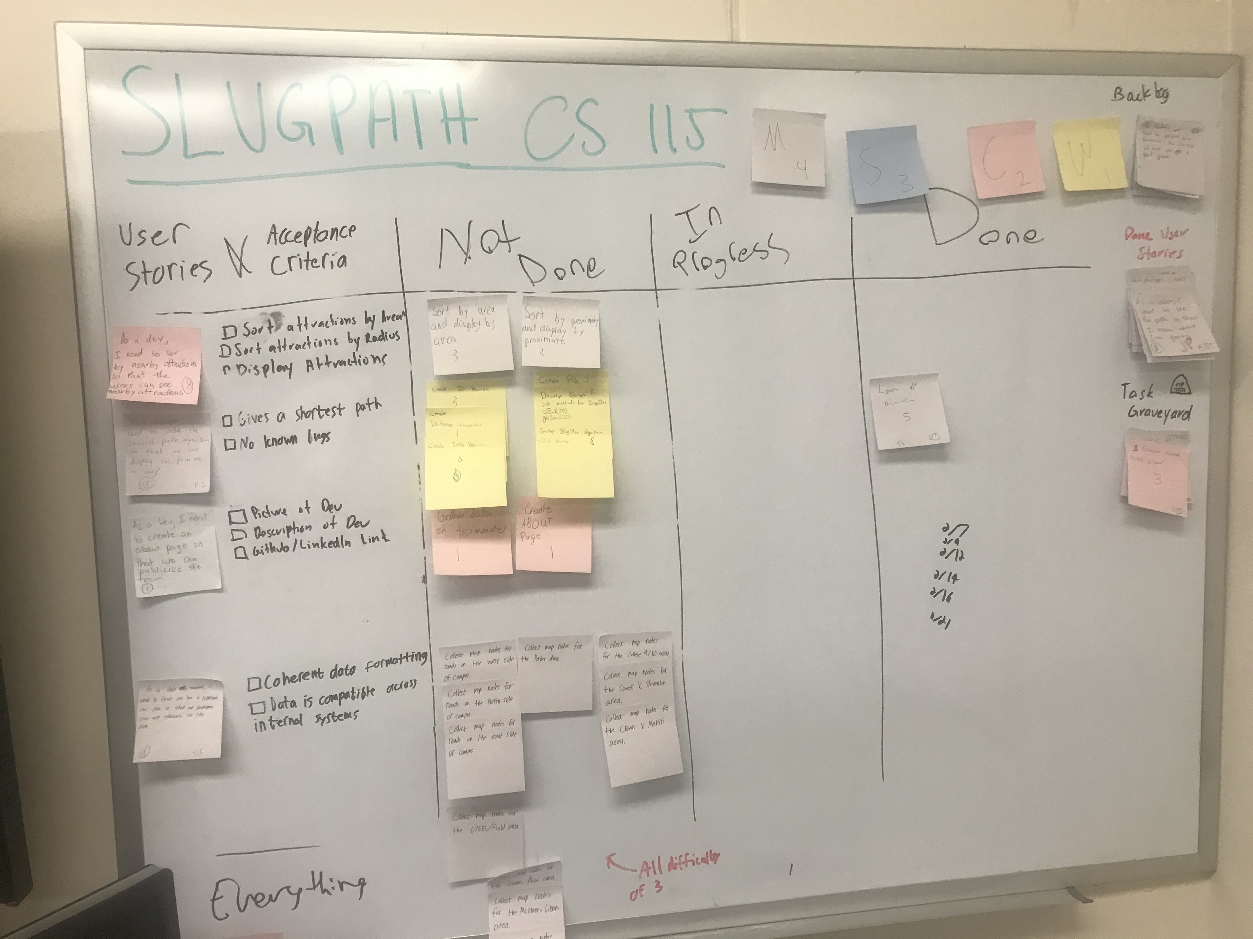

**Scrum Times:**

Monday: 12:00 PM - 12:15 PM

Wednesday: 12:00 PM - 12:15 PM (Scheduled TA visit)

Friday: 12:00 PM - 12:15 PM